**SORTING ALGORITHM VISUALIZER**

**UCS503 Software Engineering Project Report**

**End-Semester Evaluation**

**Submitted by:**

**(<102003702>) Ganesh Mittal**

**(<102003704>) Vishakha**

**(<102003710>) Neeraj Sandal**

**BE Third Year, COE**

**Group No: 3COE28**

**Submitted to:**



Mrs. Anamika Sharma

**Computer Science and Engineering Department**

**TIET, Patiala**

**December 2022**

**TABLE OF CONTENTS**

|  |  |  |
| --- | --- | --- |
| S.No. | Assignment | Page No. |
| **1.** | **Project Selection Phase** |  |
| 1.1 | Software Bid |  |
| 1.2 | Project Overview |  |
| **2.** | **Analysis Phase** |  |
| 2.1 | Use Cases |  |
| 2.1.1 | Use-Case Diagrams |  |
| 2.1.2 | Use Case Scenarios |  |
| 2.2 | Activity Diagrams |  |
| 2.3 | Data Flow Diagrams (DFDs) |  |
| 2.3.1 | DFD Level 0 |  |
| 2.3.2 | DFD Level 1 |  |
| 2.4 | Software Requirement Specification in IEEE Format |  |
| 2.5 | User Story Cards |  |
| **3.** | **Design Phase** |  |
| 3.1 | Class Diagram and Object Diagram |  |
| 3.2 | Sequence Diagram |  |
| 3.3 | Database Design : ER Diagram |  |
| **4.** | **Implementation** |  |
| 4.1 | Component Diagrams |  |
| 4.2 | Deployment Diagrams |  |
| 4.3 | Screenshots of Working Project |  |
| **5.** | **Testing** |  |
| 5.1 | Cyclomatic Complexity(All modules) |  |
| 5.2 | Test Cases |  |

* 1. **Software Bid**

Group : 4 Dated: 08-08-2022

# Team Name: Hustlers

**Team ID (will be assigned by Instructor):**

Please enter the names of your Preferred Team Members. :

* You are required to form **a three to four person** teams’
* Choose your team members wisely. You will not be allowed to change teams.

|  |  |  |  |  |
| --- | --- | --- | --- | --- |
| Name | Roll No | Project Experience | Programming Language used | Signature |
| Ganesh Mittal | 102003702 | Mess management System | SQL, MySQL, HTML,CSS |  |
| Vishakha | 102003704 | Airport Management System | SQL, MySQL,  HTML,Javascript |  |
| Neeraj Sandal | 102003710 | Android app | HTML,CSS,DSA |  |
|  |  |  |  |  |

# Programming Language / Environment Experience

List the languages you are most comfortable developing in, **as a team**, in your order of preference. Many of the projects involve Java or C/C++ programming.

1. C++

1. HTML
2. JavaScript
3. Bootstrap

# Choices of Projects:

Please select **four projects** your team would like to work on, by order of preference: [Write at least one paragraph for each choice (motivation, the reason for the choice, feasibility analysis, etc.)]

|  |  |
| --- | --- |
| First Choice | Sorting Algorithm Visualizer  An animated way to explain the sorting algorithms in an interactive way. |
| Second Choice | Learning Management System (LMS)  A software application or web-based technology is used to plan, implement and assess a specific learning process. |
| Third Choice | Fingerprint Scanner  A scanner system that can be used for attendance system by scanning fingerprints. |
| Fourth Choice | Khatta Book App  An app to create bills online for small shopkeepers. |

* 1. **Project Overview**

This project discusses a study performed on animating sorting algorithms as a learning aid for classroom instruction. The web-application animation tool was created to visualize six common sorting algorithms: Selection Sort, Bubble Sort, Insertion Sort, Heap Sort, Quick Sort, and Merge Sort. The animation tool would represent data as a bar graph and dot plot. After selecting a data ordering algorithm, the user can run an automated animation or step through it at their own pace.

**2.1.1 Use Case Diagram**

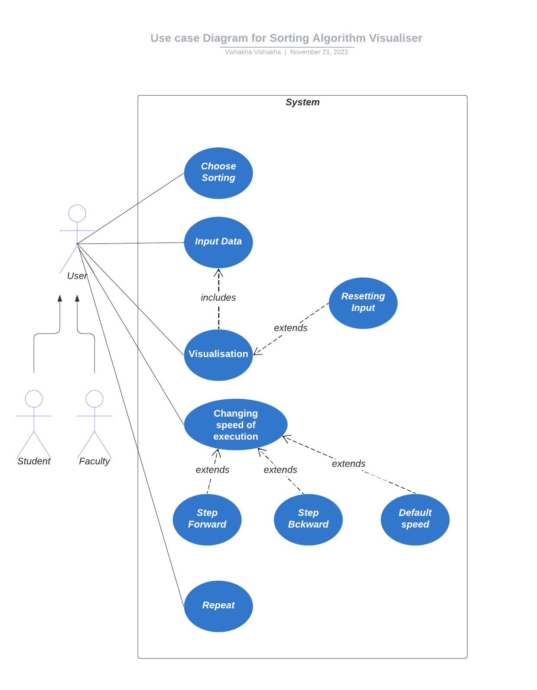

**2.1.2 Use Case Scenarios**

**Use case Scenario 1**

|  |
| --- |
|  |

6. Modification History: 10-Oct-2022

5.3 Post Condition:

User inputs the data and then executes the algorithm.

5.2 Task Sequence:

1. User enters the website and selects the type of sorting.

2. After selection of particular sort, information related to that sorting will be provided.

3. Pseudocode , time complexity and space complexity will displayed.

5.1 Pre-Conditions:

5. Description:

It allows user to select particular type of sorting from the given list.

7. Author: Ganesh , Neeraj, Vishakha

User

4. Actors

1

Choose Sorting

Choose Sorting

3. Use Case Id

2. Abbreviated Title

1. Use Case Title

**Use case Scenario 2**

|  |
| --- |
|  |

5.3 Post Condition:

During visualization, user sets its execution speed accordingly with the feature of “step forward” and “step backward”.

6. Modification History: 14-Oct-2022

7. Author: Ganesh , Neeraj, Vishakha

5.2 Task Sequence:

After choosing a particular sort with input data, user is directed for visual execution of that algorithm.

5.1 Pre-Conditions:

Selection of sorting with considerable size of input data.

5. Description:

It allows user to understand the working of its selected sorting algorithm i.e. its step by step execution in a statistical way.

User

4. Actors

2

Visualisation

Visualisation

3. Use Case Id

2. Abbreviated Title

1. Use Case Title

**Use case Scenario 3**

|  |
| --- |
|  |

5.2 Task Sequence:

At the time of execution, user can modify the execution speed.

5.1 Pre-Conditions:

User must execute particular sorting algorithm.

5.3 Post Condition:

User can repeat the whole execution.

6. Modification History: 19-Oct-2022

5. Description:

Here the user manages the execution speed accordingly(default,step forward,step backward)

7. Author: Ganesh , Neeraj, Vishakha

User

4. Actors

3

Exe. speed

Execution Speed

3. Use Case Id

2. Abbreviated Title

1. Use Case Title

**2.2 Activity Diagram**

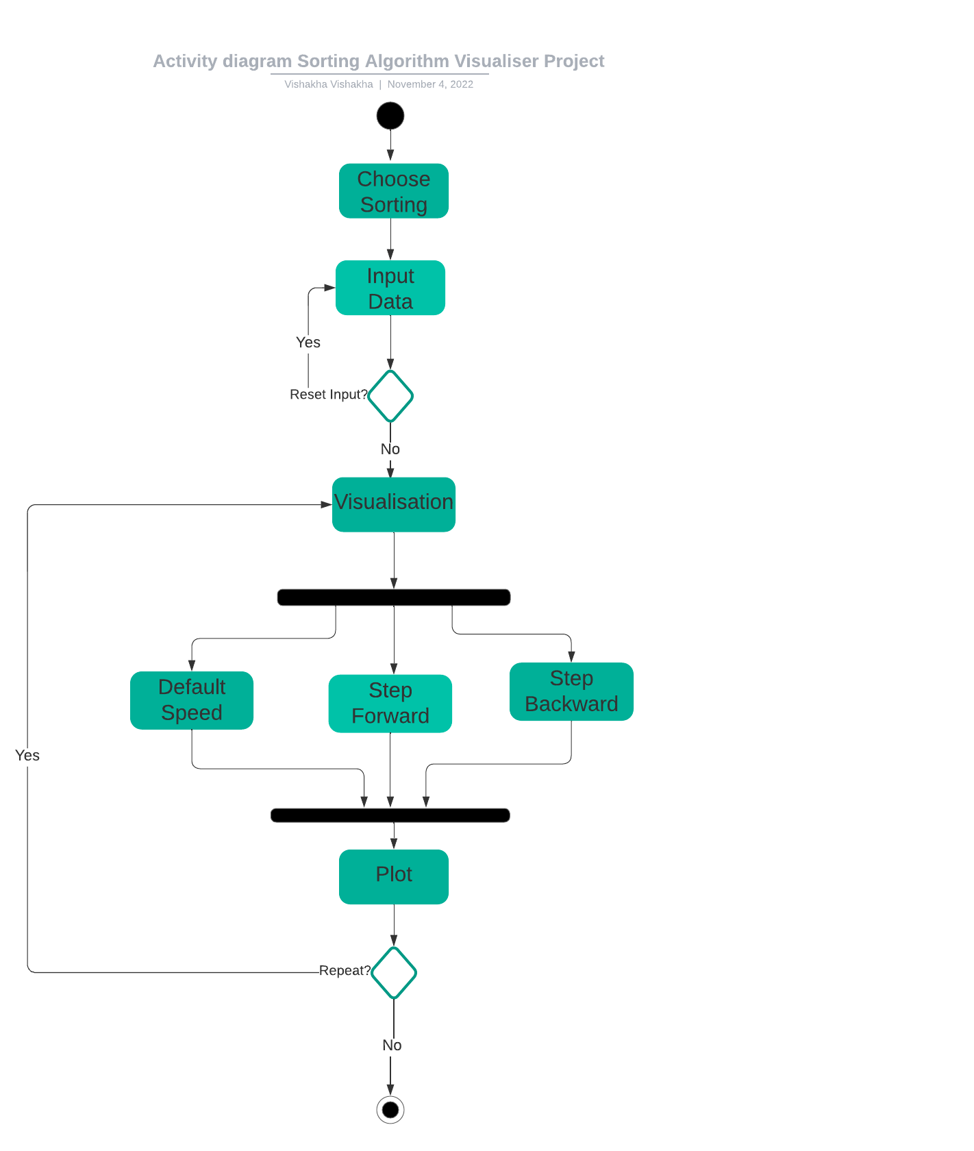

**2.3.1 DFD Level-0**

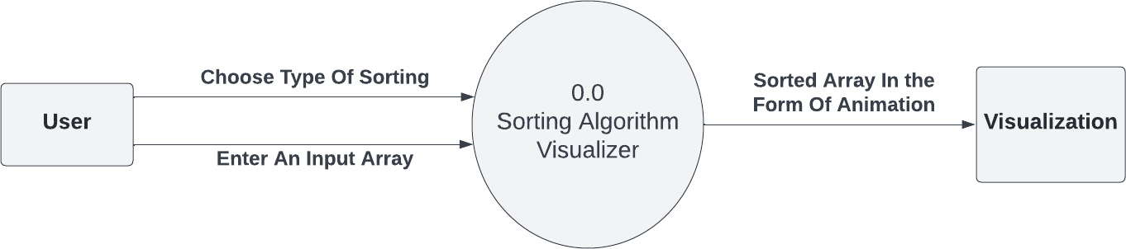

**2.3.2 DFD Level-1**

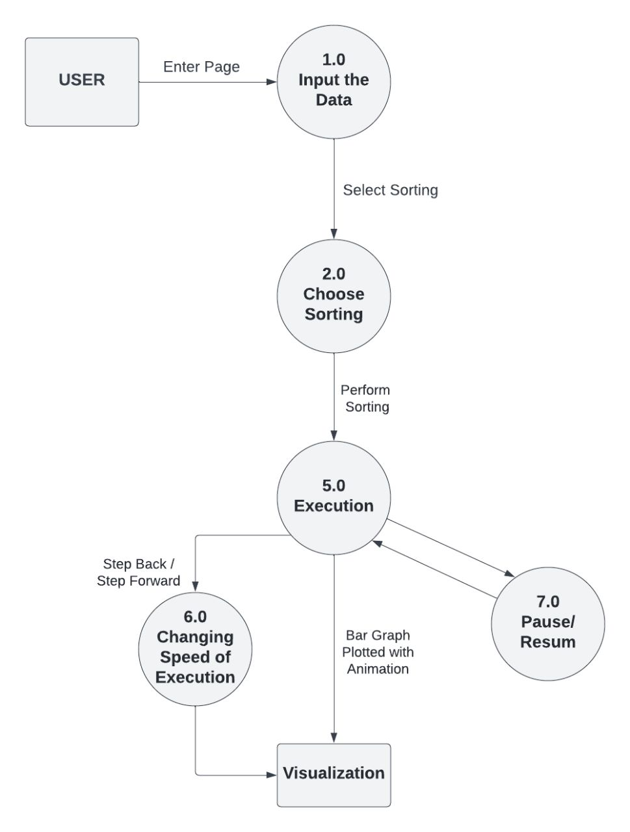

**2.4 Software Requirement Specification in IEEE Format**

**Software Requirements**

**Specification**

**for**

**<Sorting Algorithm Visualiser**

**Project >**

# Version 1.0 approved

# Prepared by :

**Ganesh Mittal<102003702>**

**Vishakha<102003704>**

**Neeraj Sandal<102003710>**

# <Thapar Institute of Engineering and Technology, Patiala>

**<Date:12-09-2022 >**

**Table of Contents**

Table of Contents 13

Revision History 13

1. Introduction 14

Purpose 14

Definitions, Acronyms, and Abbreviations… 14

Intended Audience and Reading Suggestions 14

Product Scope 16

References 17

1. Overall Description 17

Product Perspective 17

Product Functions 18

User Classes and Characteristics 18

Operating Environment 18

Design and Implementation Constraints 19

User Documentation 19

1. External Interface Requirements 20

User Interfaces 20

Hardware Interfaces 20

Software Interfaces 20

1. System Features 21

Functional Requirements 21

1. Other Nonfunctional Requirements 22

Performance Requirements 22

Security Requirements 22

Business Rules 23

**Revision History**

|  |  |  |  |
| --- | --- | --- | --- |
| **Name** | **Date** | **Reason For Changes** | **Version** |
|  |  |  |  |
|  |  |  |  |

# Introduction

### Purpose

This Project is based on the visualization of the algorithms (Selection Sort, Insertion Sort, Bubble Sort). It creates a teaching support software. This application supports a graphic visualization of selected algorithms on randomly generated or manually created arrays, step- by-step execution possibilities, and the current state of variables.

### Definitions, Acronyms, and Abbreviations Definitions

**Table 1 explains the most commonly used terms in this SRS document.**

|  |  |  |
| --- | --- | --- |
| **Sr. No.** | **Term** | **Definitions** |
| 1. | Algorithm | An algorithm is a set of instructions for solving a problem or accomplishing a task. An example of an algorithm is a recipe, which consists of specific instructions for preparing a dish or meal. Every computerized device uses algorithms to perform its functions in the form of hardware- or software- based routines. |
| 2. | Sorting | Sorting refers to arranging data in a particular format. The sorting algorithm specifies the way to put data in a specific order. Most standard charges are in numerical or lexicographical order. |
| 3. | Complexity | The complexity of an algorithm is a function describing the algorithm’s efficiency in terms of the amount of data the algorithm must process. Usually, there are natural units for the domain and range of this function. There are two main complexity measures of the efficiency of an algorithm:   * Time complexity is a function describing the amount of time an algorithm takes in terms of the amount of |

|  |  |  |
| --- | --- | --- |
|  |  | input to the algorithm.   * Space complexity is a function describing the amount of extra memory (space) an algorithm takes regarding the amount of input to the algorithm. |
| 4. | Traverse | To traverse an array means to access each element (item) stored in the collection so that the data can be checked or used as part of a process. |
| 5. | Swap | Swapping is a valuable technique that enables a computer to execute programs and manipulate data files more significantly than the main memory. |
| 6. | Pseudo Code | Pseudocode is a detailed yet readable description of what a computer program or algorithm must do, expressed in a formally-styled natural language rather than a programming language. |
| 7. | Dry Run | A dry run is the process of a programmer manually working through their code to trace the value of variables. There is no software involved in this process. Traditionally, a dry run would involve a printout of the code. |
| 8. | Array | An array is a linear data structure that collects elements of the same data type and stores them in contiguous and adjacent memory locations |

### List of Abbreviations

**Table 2 gives the complete form of the most commonly used mnemonics in this SRS document.**

|  |  |  |
| --- | --- | --- |
| **Sr. No.** | **Mnemonic** | **Full Forms** |
| 1. | JS | JavaScript |
| 2. | URL | Uniform Resource Locator |
| 3. | HTML | Hypertext Markup Language |
| 4. | CSS | Cascading Style Sheets |
| 5. | DOM | Document Object Model |
| 6. | UI | User Interface |
| 7. | UX | User Experience |
| 8. | SDLC | Software Development Life Cycle |
| 9. | HD | High-Level Design |
| 10. | LLD | Low-Level Design |

### Product Scope

This software system will help students of computer science understand algorithms with the help of animations and run-time animation of new algorithms. The software will be designed to be more interactive and user-friendly so that students can grasp the working of algorithms. By enabling them to write their algorithm and see the performance and working of it at run time. Teachers can also use this system because it would give them a better medium to teach algorithms rather than relying on PowerPoint slides.

### References

* + “Algorithm Visualizer” by Barnini Goswami, Anushka Dhar, Akash Gupta, Antriksh Gupta, Volume 3 Issue 03 March 2021, International Research Journal of Modernization in Engineering Technology and Science, retrieved on 1 sept 2022
  + [https://digitalcommons.ric.edu/cgi/viewcontent.cgi?article=1129&context=honors_pr](https://digitalcommons.ric.edu/cgi/viewcontent.cgi?article=1129&context=honors_projects) [ojects](https://digitalcommons.ric.edu/cgi/viewcontent.cgi?article=1129&context=honors_projects)

retrieved on 1st sept 2022

* + <https://theses.cz/id/3w4s3a/Mykhailo-Klunko-bc-thesis.pdf> retrieved on 2nd sept 2022
  + “Visualizing sorting algorithms” by Brian Faria, Rhode Island College, 2017. Retrieved on 2nd sept 2022.
  + “ViSA: Visualization of Sorting Algorithms” by Tihomir Orehovački, ResearchGate, May 2012, retrieved on 10th sept 2022.
  + IEEE Recommended Practice for Software Requirements Specifications, retrieved 29 Aug 2022

from <https://ieeexplore.ieee.org/document/278253>

* + Open proj, retrieved on 5th sept 2022
  + Lucid chart, retrieved on 5th sept 2022
  + Creatly, retrieved on 5th sept 2022

# Overall Description

### Product Perspective

The central perspective of this project is to help beginners to be able to visualize the basic algorithms and get a better understanding of the underlying operations. And obviously, it is needless to say that anyone willing to contribute is voted to use their creativity to make the visualizations even better and more attractive. One can add new Algorithms and visualization of their choice too.

* This project is for educational purposes.
* Extract the required feature and classify it among others.

### Product Functions

The product should be able to perform the following operations:

* + The product should work on different arrays and sorting algorithms (Insertion Sort, Bubble Sort, Selection Sort).
  + User should be able to restart or pause the visualization.
  + It should be able to visualize each change made in the given array step by step in a playful way.
  + User must be able to step back or forward during execution.
  + It may also have the functionality of generating a random array of random size.
  + Indexes of the array should be shown throughout the execution.

### User Classes and Characteristics

The goal is to design a web app to understand the sorting algorithms in a playful way that will be beneficial for the following type of users :

* **Students:** It will act as an e-learning platform for students to understand the concept of sorting algorithms. It will help the students who cannot understand the algorithm from code or pseudo code. This visualizer will act as a dry run which will help the student to visualize the algorithm and easily code the Sorting Algorithms.
* **Teaching faculty**: It will help the Faculty teach students innovatively.

Rather than totally relying on the PowerPoint presentation and whiteboards, the learning is dull. So, going through these types of visualization makes the teaching better, and the student will be able to grasp more.

### Operating Environment

Since Java is cross-platform, you may use the application within the most popular PC operating systems where Java is supported. Here are given minimal system requirements for several operating systems.

Requirements:

* Operating system: minimum Windows XP SP3 or Mac OS X 10.4.10 or Ubuntu 8.04
* Java: Java SE 8 with minimum update 40 (8u40) or update 51 (8u51) in case of Windows 10 operating system
* Processor: Dual-Core processor, 1.8 GHz
* Memory: 512MB of RAM (1GB recommended)

### Design and Implementation Constraints.

The following list presents the constraints, assumptions, dependencies, or guidelines that are imposed upon implementation of the Sorting Algorithm Visualizer

* Only a few visuals can be supported on the display screen due to the compact form factor.
* There is no need for memory.
* The product must have an intuitive user interface that is easy for everyone.
* The software should load quickly, and transaction processing shouldn't take more than three seconds.
* The product is available for laptops and PCs only.

### User Documentation

* + User Manual
  + Implementation Manual

# External Interface Requirements

### User Interfaces

The user interface will provide a good look and effects to make it more user-friendly. Teachers and students can operate the system very efficiently.

### Hardware Interfaces

* + Processor 11th Gen Intel(R) Core(TM) i5-1135G7 @ 2.40GHz 1.38 GHz
  + Installed RAM8.00 GB (7.73 GB usable)
  + System type 64-bit operating system, x64-based processor
  + EditionWindows 11 Home Single Language
  + Version 21H2
  + OS build 22000.856
  + Experience Windows Feature Experience Pack 1000.22000.856.0
  + Memory 512GB (SSD)

### Software Interfaces

This software uses object-oriented and functional programming paradigms to organize the code. The use of HTML5 (Hypertext Markup Language 5), JavaScript, and CSS combine to form this project's implementation (Cascading Style Sheets). Our web app can run on operating systems like Ubuntu and some web browsers, like Mozilla Firefox, Google Chrome, and Safari integration.

# System Features

### Functional Requirements

Our product will provide a user-friendly interface for the user. The user can watch the animation of the array being sorted using three different sorting algorithms. The user has the advantage of changing the elements of the collection as well as the size of the collection; to rewind the step, there is one step back button provided on the interface.

|  |  |
| --- | --- |
| **Functional**  **Requirements** | **Function** |
| F. Req. 1 | User-friendly Interface, where users can select the sorting they  want to perform |
| F. Req. 2 | After selecting the type of sort, a user can input the size of an array  accordingly, or there will be a random generation of array elements. |
| F. Req. 3 | Clicking on the run button starts executing the algorithm, and how  sorting is done is shown animatedly. |
| F. Req. 4 | There is a functionality to step forward or backward while an array  is in execution. |

### Visualization of algorithms

Learning algorithms through visualizations can help students grasp algorithms better. Excellent and basic knowledge of DSA is essential to becoming a good developer.

Algo Assist ensures to provides clear visualization and helps students understand algorithms.

# Other Non-functional Requirements

### Performance Requirements

Performance requirements for Algorithm Visualizer can be categorized into three. They are as follows:

* + Response Time:

It depends upon the time complexity of the algorithm you have chosen.

* + Capacity:

The application is standalone. There is no capacity requirement.

* + Resource utilization:
    - 32-bit dual-core 2Ghz CPU with SSE2 support.
    - 2 GB RAM
    - OpenGL 2.1 compatible graphics card with 512 MB RAM

### Safety And Security Requirements

Because this is an open web app available for free to everyone. There are no login credentials required to access our web app. So your credentials will remain secure with you.

### Reliability:

As the application is standalone and does not depend on any server or database, there is no concern about keeping that kind of component up and running all the time. This indicates that there will not be any availability problems either. Accordingly, as long as there is no problem with the user's operating system, it is expected that the program will go on processing smoothly.

### Usability:

The user does not need to tackle any problems with any problems regarding the GUI as it aims to be simple but functional. The time for providing the result is sought to be kept minimum.

### Business Rules

Anyone can use this application without considering any minimum requirement

**2.5 User Story Cards**

**User Story Card : Front Of Card**



**User Story Card: Back side of Card**

**Success:**

1. Interactive homepage with time delay.
2. User-Friendly
3. Navbar added to minimize scrolling effort.

**Failure:**

1. Heavy web app may take a longer time to load on Netlify.

**User Story Card : Front Of Card**

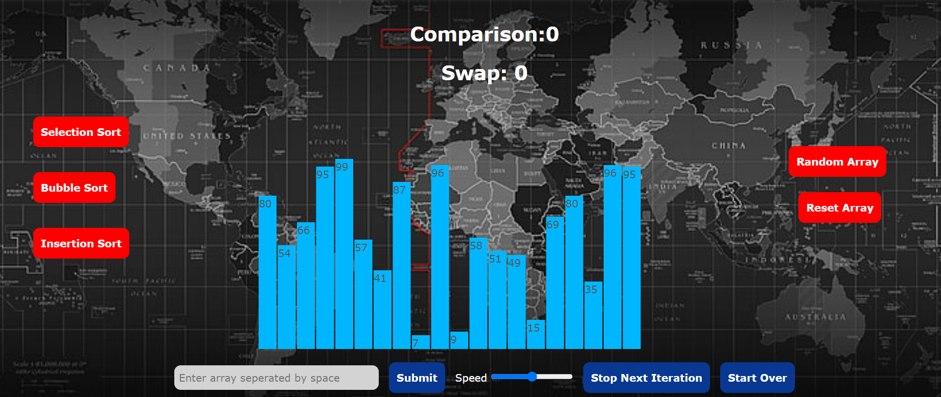

**User Story Card: Back side of Card**

**Success:**

1. Execution speed can be adjusted according to need.
2. User can reset the array.
3. Random array can be generated in the range 1-100 of size 20.
4. User can pause/resume the iteration process.
5. Users can get information of any particular sort with code/complexities.

**Failure:**

1. Less responsive on other devices (like mobile phones).
2. Skip forward/backward option is not included.

**Constraints:**

1. Random array generates an array of size 20 only.
2. User cannot watch the respective pseudo code along with visualization.

**3.1 Class diagram and Object diagram**

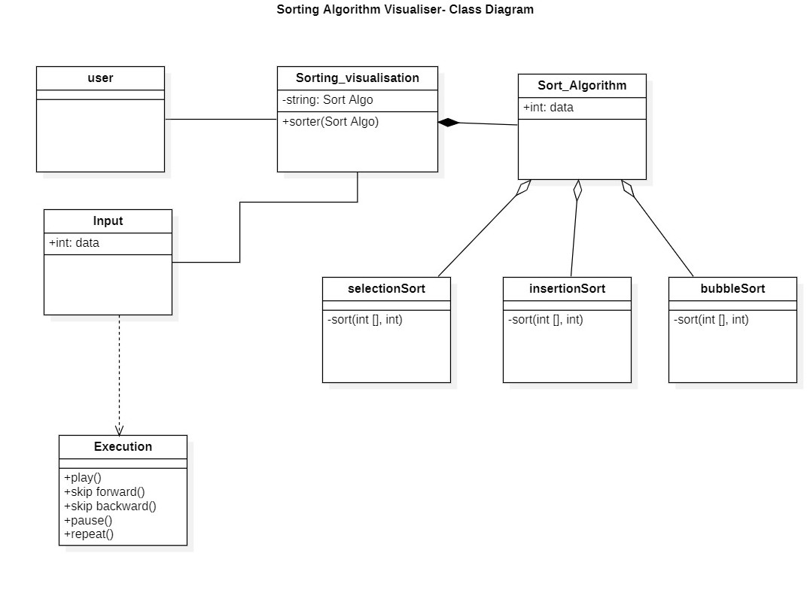

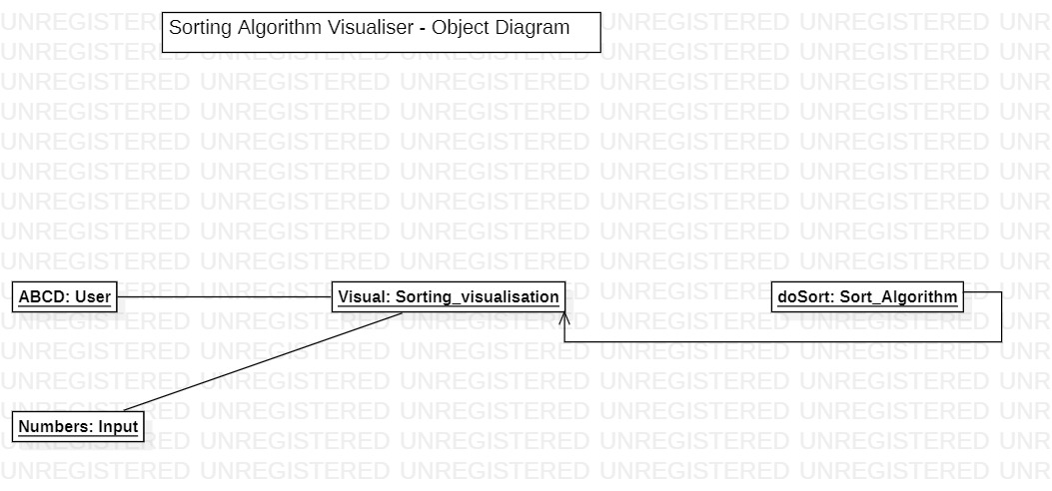

**3.2 Sequence Diagram**

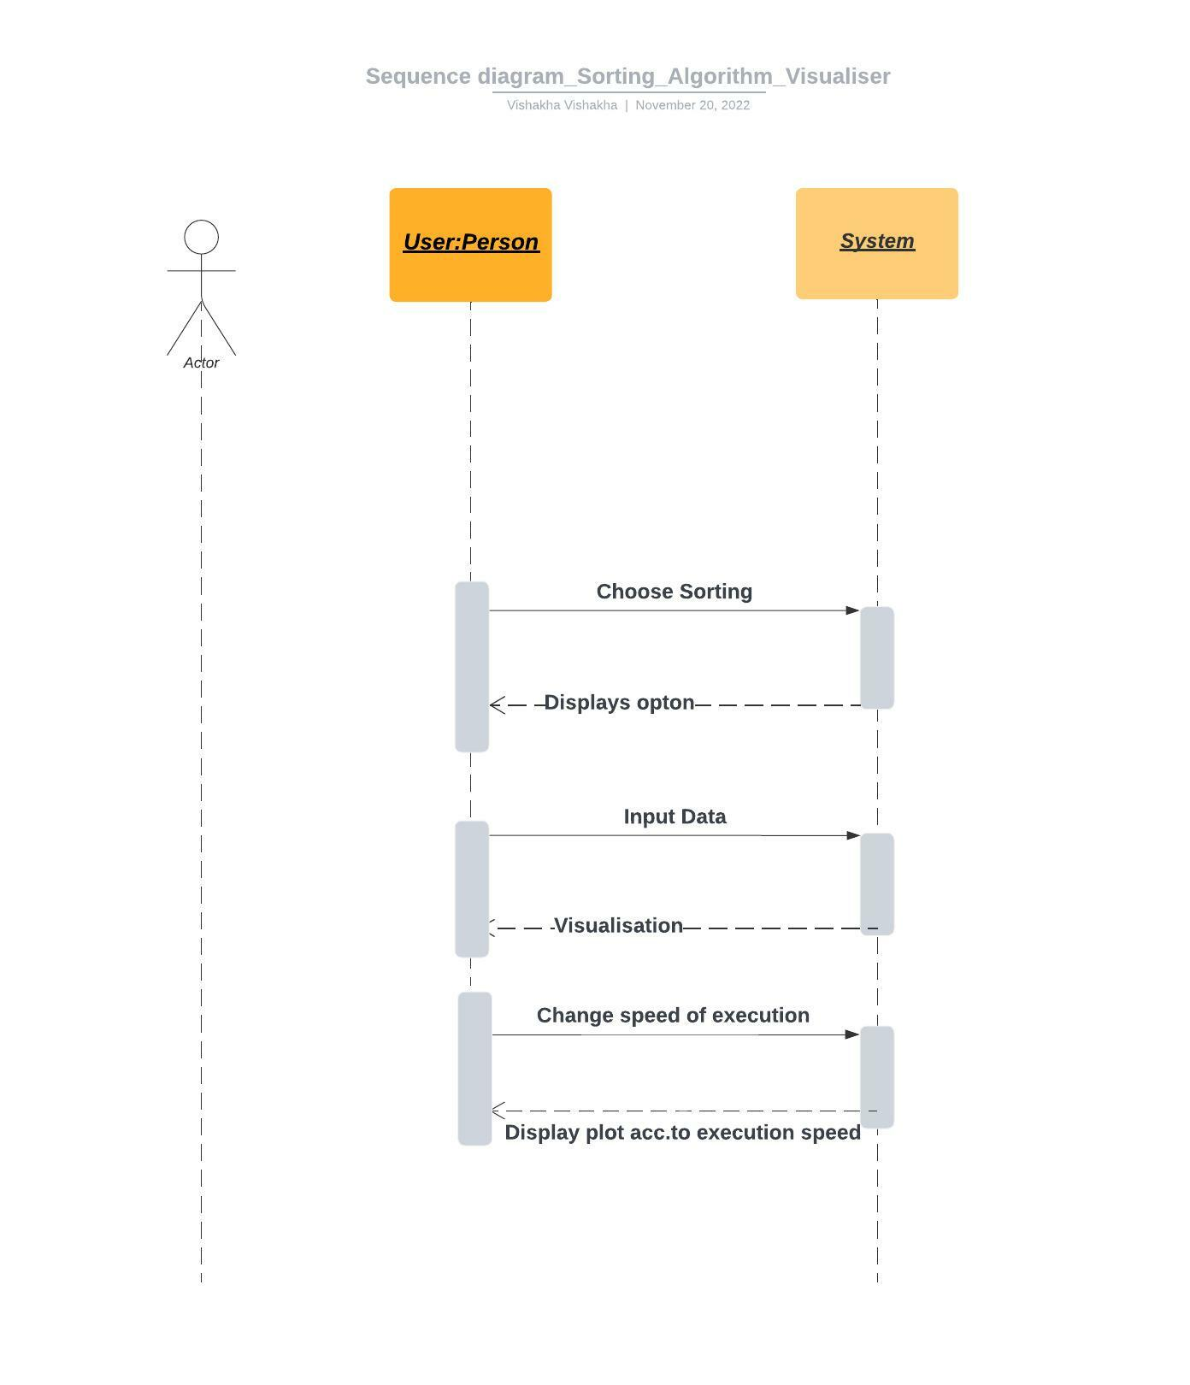

**3.3 Database Design:ER Diagram**

As there is no database in our project and only one entity i.e. user is there. So ,ER diagram is not feasible to make.

**4.1 Component Diagram**

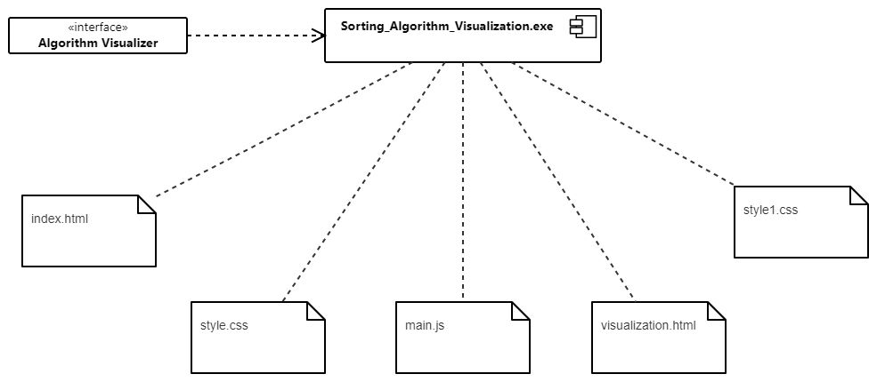

**4.2 Deployment Diagram**

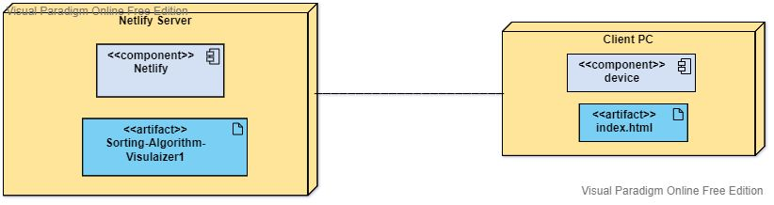

**4.3 Screenshot of Working Project**

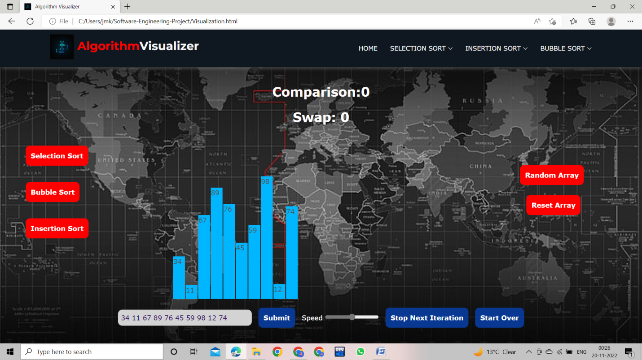

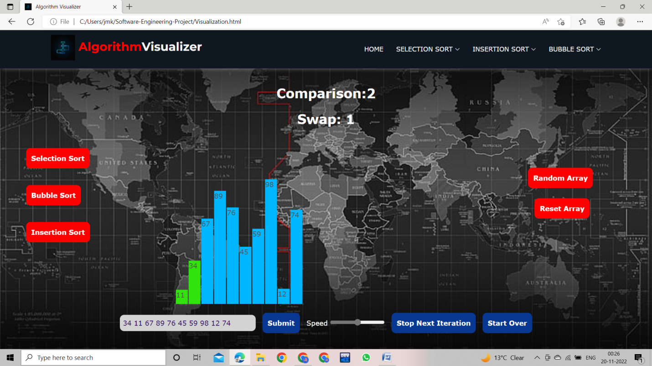

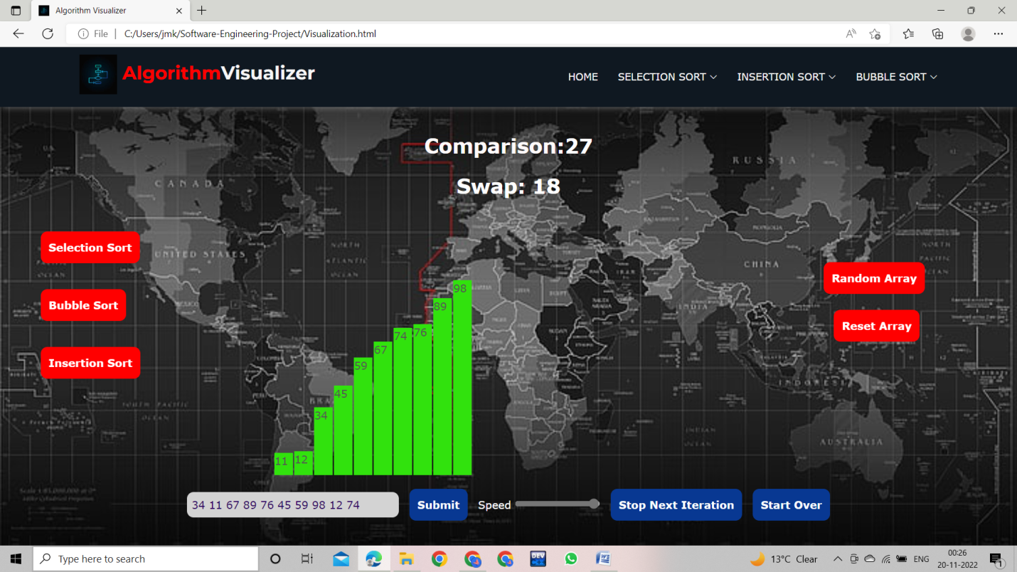

**5.1 Cyclomatic Complexity(All modules)**

**Cyclomatic complexity** of a code section is the quantitative measure of the number of linearly independent paths in it. It is a software metric used to indicate the complexity of a program. It is computed using the Control Flow Graph of the program. The nodes in the graph indicate the smallest group of commands of a program, and a directed edge in it connects the two nodes i.e. if second command might immediately follow the first command.

Cyclomatic Complexity of our project is O(4).

**5.2 Test Cases**

|  |
| --- |
| **Test Case #: 1 Test Case Name: Random Input Array Page: 1 of 1**  **System: Laptop/PC Subsystem: None**  **Designed by: Neeraj,Vishakha,Ganesh Design Date: 1/11/2022**  **Executed by: Gaurav Gupta Execution Date:16/11/2022**  **Short Description: Test the Working of Visualiser** |

|  |
| --- |
| **Pre-Conditions:**  User must have the basic information of what is meant by sorting.  The User has access to the Internet |

|  |  |  |  |
| --- | --- | --- | --- |
| **Step** | **Action** | **Expected System Response** | **Pass/Fail** |
| 1 | Click on Random Array | Array is generated in the form of bar plots of size 20. | Pass |
| 2 | Choose the Sorting | Animation begins showing the execution step-wise | Pass |
| 3 | Speed Slider | Changes the speed of Execution | Pass |
| 4 | Click Stop/Start-Over Button | Stops the execution and resume it | Pass as Expected |
| 5 | Click Reset Array Button | Reset The Array and Pages gets reloaded | Pass |

|  |
| --- |
| **Post-Conditions:**  User gets the Final Sorted Array at the end. |

|  |
| --- |
| **Test Case #:2 Test Case Name: Positive Input Array Page: 1 of 1**  **System: Laptop/PC Subsystem: None**  **Designed by: Neeraj , Vishakha , Ganesh Design Date: 1/11/2022**  **Executed by: Darpan Mittal Execution Date:16/11/2022**  **Short Description: Test the Working of Visualiser** |

|  |
| --- |
| **Pre-Conditions:**  The User has access to the Internet |

|  |  |  |  |
| --- | --- | --- | --- |
| **Step** | **Action** | **Expected System Response** | **Pass/Fail** |
| 1 | Enter an own Arrayof Positve Numbers | Array is generated in the form of bar plots according to the input | Pass |
| 2 | Choose the Sorting | Execution Begins according to choosen sorting. | Pass |
| 3 | Speed Slider | Changes the speed of Execution | Pass |
| 4 | Click Stop/Start-Over Button | Stops the execution and resume it | Pass as Expected |
| 5 | Click Reset Array Button | Reset The Array and Pages gets reloaded | Pass |

|  |
| --- |
| **Post-Conditions:**  User gets the Final Sorted Array at the end and got understood how it works. |

|  |
| --- |
| **Test Case #: 3 Test Case Name: Signed Input Array Page: 1 of 1**  **System: Laptop/PC Subsystem: None**  **Designed by: Neeraj , Vishakha , Ganesh Design Date: 1/11/2022**  **Executed by: Anmol Assi Execution Date:16/11/2022**  **Short Description: Test the Working of Visualiser** |

|  |
| --- |
| **Pre-Conditions:**  User must have the basic information of what is meant by sorting.  The User has access to the Internet |

|  |  |  |  |
| --- | --- | --- | --- |
| **Step** | **Action** | **Expected System Response** | **Pass/Fail** |
| 1 | Input the Array containing both Positive and Negative Numbers. | Bar Plots are formed containing both Positive and Negative numbers. | Pass |
| 2 | Choose the Sorting | Animation begins showing the execution step-wise | Pass |
| 3 | Speed Slider | Manages the speed of Execution according to the need. | Pass |
| 4 | Click Stop/Start-Over Button | Stops the execution and resume it | Pass as Expected |
| 5 | Click Reset Array Button | Delete the array and reloads the page | Pass |

|  |
| --- |
| **Post-Conditions:**  User gets the Final Sorted Array at the end. |

|  |
| --- |
| **Test Case #: 4 Test Case Name: Large Input Array Page: 1 of 1**  **System: Laptop/PC Subsystem: None**  **Designed by: Neeraj , Vishakha , Ganesh Design Date: 1/11/2022**  **Executed by: Amit Kumar Execution Date:16/11/2022**  **Short Description: Test the Working of Visualiser** |

|  |
| --- |
| **Pre-Conditions:**  User must have the basic information of what is meant by sorting.  The User has access to the Internet |

|  |  |  |  |
| --- | --- | --- | --- |
| **Step** | **Action** | **Expected System Response** | **Pass/Fail** |
| 1 | Input the own Array of larger size say (100) | Bar Plots are formed, but only showing first 35 numbers only. | Fail |
| 2 | Choose the Sorting | Execution started according to the chosen sort | Pass |
| 3 | Speed Slider | Increases or Decreases the speed of execution. | Pass |
| 4 | Click Stop/Start-Over Button | Pause the execution and resume it. | Pass as Expected |
| 5 | Click Reset Array Button | Reloads the page and Input gets deleted. | Pass |

|  |
| --- |
| **Post-Conditions:**  User gets the Final Sorted Array at the end. |